**GENIUS GUN - DEMO HOUSE**

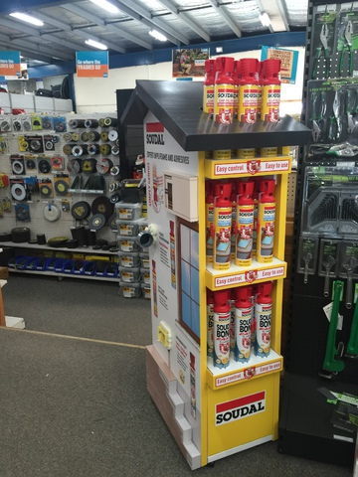**Add a touch of…genius!**

Just landed, world class in-store display to showcase the unique Genius Gun products,

1. Gap Filling Foam (500ml & 750ml)
2. Flexible Insulation Foam
3. Soudabond Easy

Don’t miss your chance to boost your sales, only 100 available.

Stock order,

2 boxes (24) Gap Filling Foam 500ml

2 boxes (24) Gap Filling Foam 750ml

2 boxes (24) Flex Insulation Foam 750ml

2 boxes (24) Soudabond Easy 750ml

**SIZE**

1650mm height

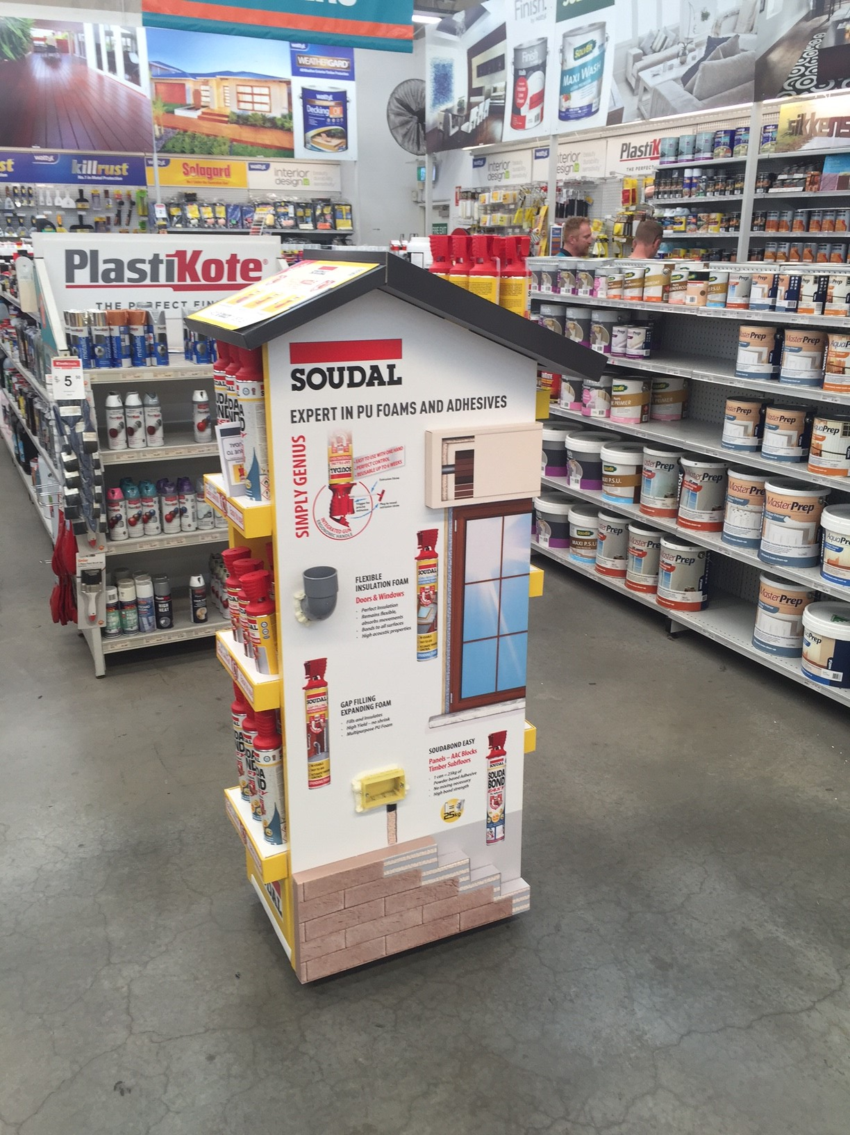500mm width

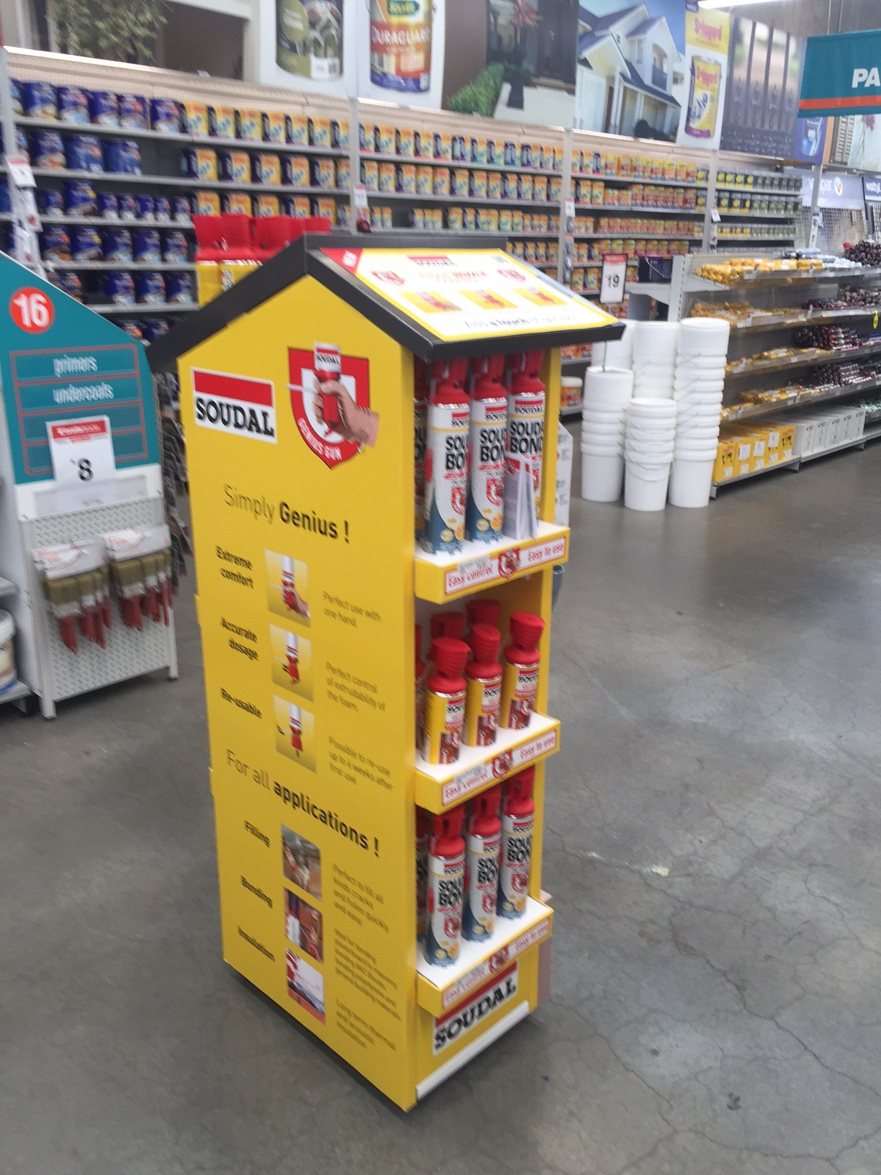720mm depth

DISPLAY IS DELIVERED COMPLETE, CANS ARE ADDED ONCE IN STORE.

ITEM CODE 320052

**GENIUS GUN - DEMO HOUSE**

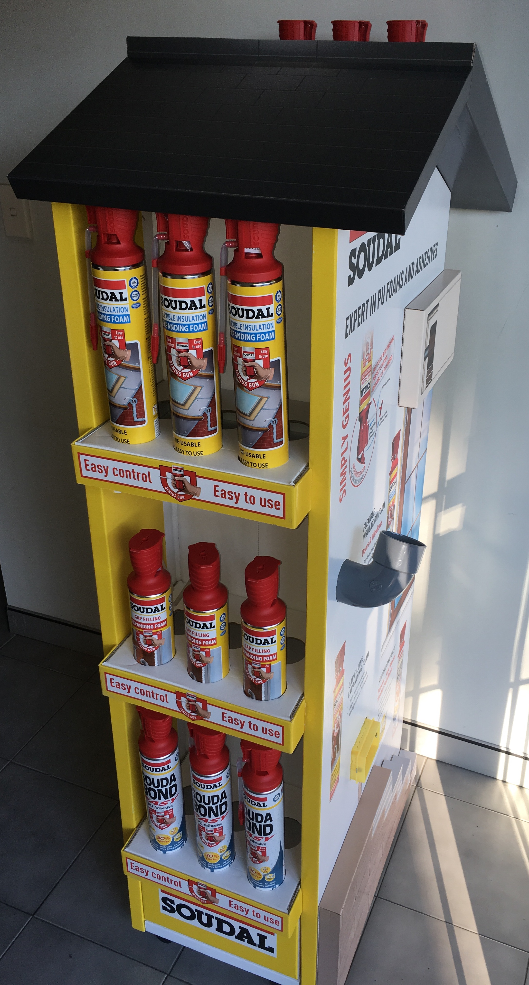

Gap Filling Foam 500ml

Flex Insulation Foam 750ml

Soudabond Easy 750ml

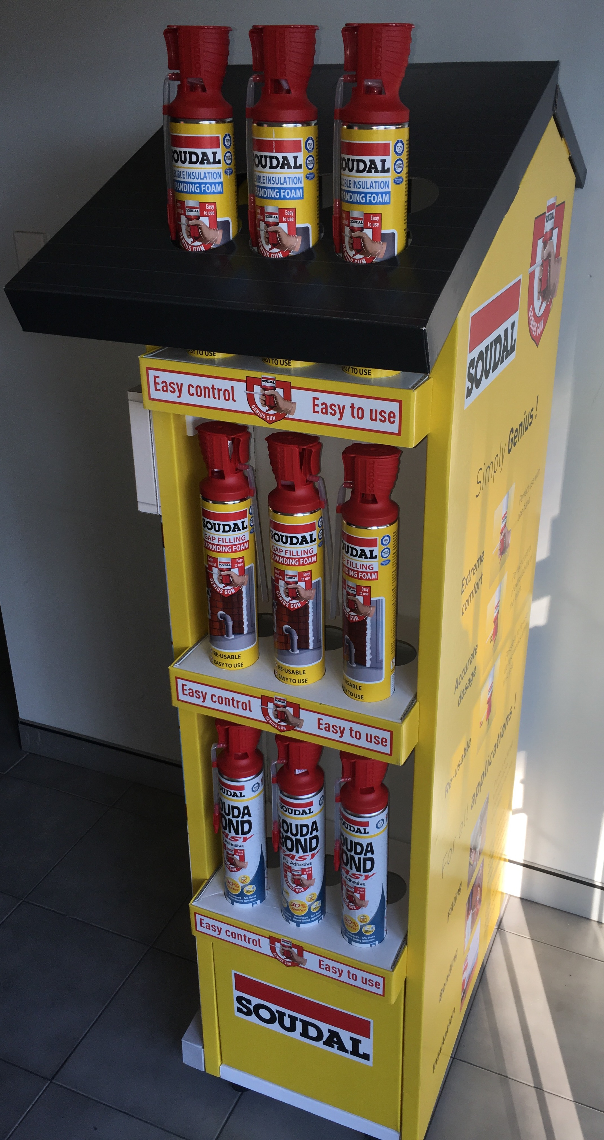

Gap Filling Foam 750ml

Flex Insulation Foam 750ml

Soudabond Easy 750ml

|  |  |
| --- | --- |
| **ORDER FORM** | |
| DATE |  |
| STORE |  |
| CONTACT |  |
| ORDER NUMBER |  |
| SEND TO | Fax 1300 04 97 81 or sales@soudal.com.au |